**SOEN 342**

**Phase 1**

**By:**

**Siddhesh Mishra ID: 40094356**

**Natheshan Rasaiah ID: 40080680**

**Amanda Marsillo ID: 40132388**

**Jonathan Perlman ID: 40094762**

**Kevin Prom ID: 40133096**

**Charlie Huang ID: 40111215**

**Joey Moarbes ID: 40108570**

**Ankita Ingle ID: 40120124**

**Samdarshi Tiwari ID: 40113256**

**GINA CODY School of Engineering and Computer Science**

**Department of Computer Science and Software Engineering**

**Concordia University**

**Abstract**

Introducing the newly developed online tutoring platform, SmartStar. When developing this new web platform, multiple comparative studies were performed to ensure the maximum amount of both user and client value were present. Throughout the course of this report, we introduce and describe the core functionalities of the platform as well as what has been observed on existing tutoring platforms currently available on the market.

**Part I: Market analysis**

**I.I Comparative study of** [**GradeSavers**](https://gradesavers.com/index.php) **:** A CEGEP and University tutoring Service

GradeSavers describes itself as having a “focus on connectivity and targeted learning objectives” and claims to do “education right”. By conducting a comparative study of the website and looking through all of their features, the key differentiating points can be extracted and a conclusion for the comparative study provided.

1. **Searchability and Curation of Content**

GradeSavers has broken down their available courses by making students self-identify as to which institution they go to, then providing them a list of specific courses offered by that institution to choose from, as shown in the figure below. 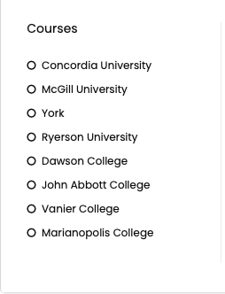

By allowing students to first pick their institution, this makes the role of trying to match a tutor with the students much more streamline, as tutors can specialize to target one specific institution. Diving deeper into this curation system, an example of an engineering student at Concordia will be used. The student therefore selects Concordia university as their institution as is presented with a menu as shown in the figure below: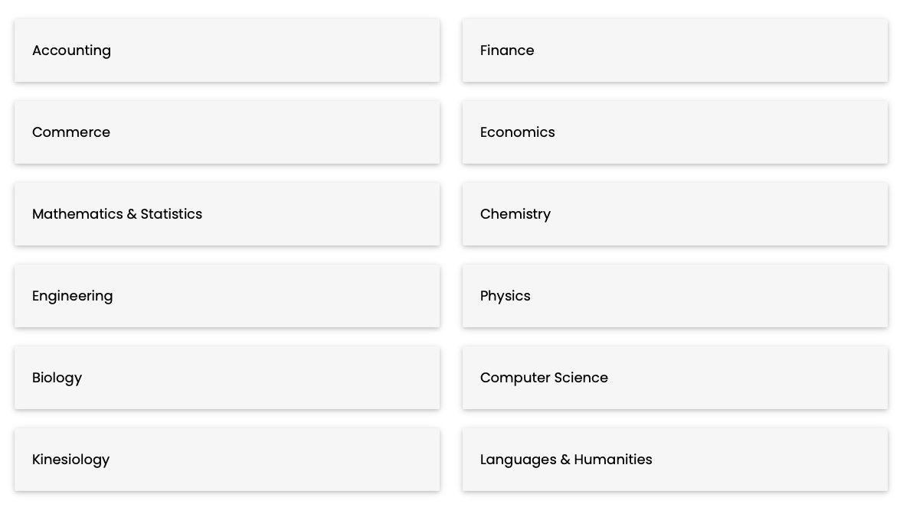

As we have taken on the persona of an engineering student, we further press on the Engineering menu option and are presented with the following: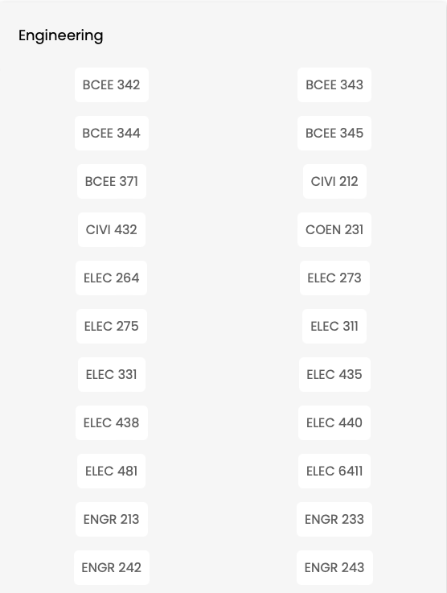

The figure above only shows a small amount of the over 80 different engineering courses GradeSavers claims to have tutors for. Therefore, the typical searchability scenario for a student on the GradeSavers website would be:

Select Institution -> Select Domain -> Select Course

This streamlines the process of trying to match a student with a tutor by having the student self-identify as to the specific course they are searching for help on and matching them with a tutoring who is assumed to be knowledgeable enough to help the student. This curation path can therefore be extrapolated for any student seeking help from any course they offer across the various institutions, making the experience consistent for all users.

1. **Selection of Tutoring Type and Pricing Transparency**

After the student has completed the self-identification process and has identified the specific course they are seeking help in, this is where multiple options are presented to the student. Taking the course of ENGR 213 as an example, selecting this course from the list brings us to the following options as shown in the figure below: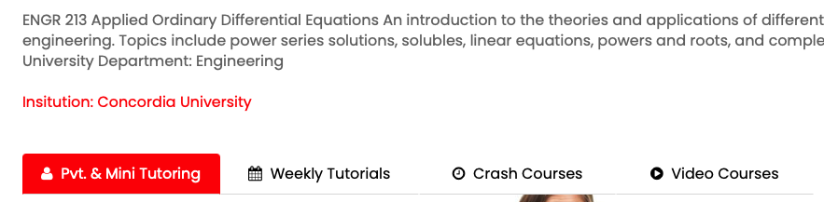

Four different options are presented to the student, and the choice as to what type of resource is needed is left entirely to the student. The first tab of private 1:1 tutoring or Mini tutoring (groups of 2-6) are presented first, in which the tutor responsible for the course and their rates are displayed as shown in the figure below: 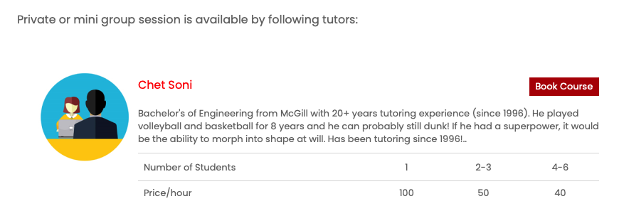

If the student is interested in a more school-like tutoring approach, the second option of weekly tutorials is then presented, in which a schedule following the university’s will be presented, with days, timings and pricing being displayed as shown below: 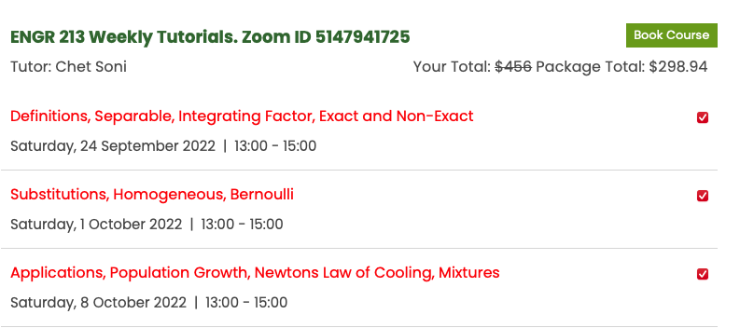

The final two options of “Crash Courses” and “Video Courses” are also available for students. These options are made available closer to exam time, with the video lectures being pre-recorded videos available for students to purchase at any time, as shown below:

What should be noted however is that even though it seems that GradeSaver has over 80+ engineering courses available for tutoring, many of these courses point to blank webpages in which no tutor, videos or courses are available. This suggests GradeSavers only focuses on courses they know will bring in high enrollment, such as general engineering courses. For example, the first year ELEC 273 class has no content on its subpage, as shown below: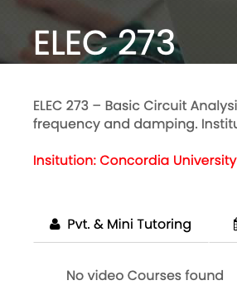

What can be said however, is that in all cases, GradeSavers has been transparent with what price they will be charging students for any type of tutoring style they pick. The individual rates of each tutor, their package deals and total pricing are displayed visibly for students to observe and help remove the barrier of having to find out the price of their tutor only when the final bill comes. GradeSavers does seem to have employed the “false discount” strategy of advertising a high price at first, then saying that the same content is now available at a much more discounted price, even if the content was never sold at the original price to begin with.

1. **Forum Discussions and FAQ Section**

Alongside offering tutoring services, GradeSavers has also implemented a forum or “Student Community” subpage on their website. This forum seems to address a range of topics, from study resources, specific universities, buying and selling textbooks, and international students. This forum has a simplistic design and utilises a scrollable design to present the most popular threads at the top first, then presenting the individual contributions in chronological order once pressed as shown below: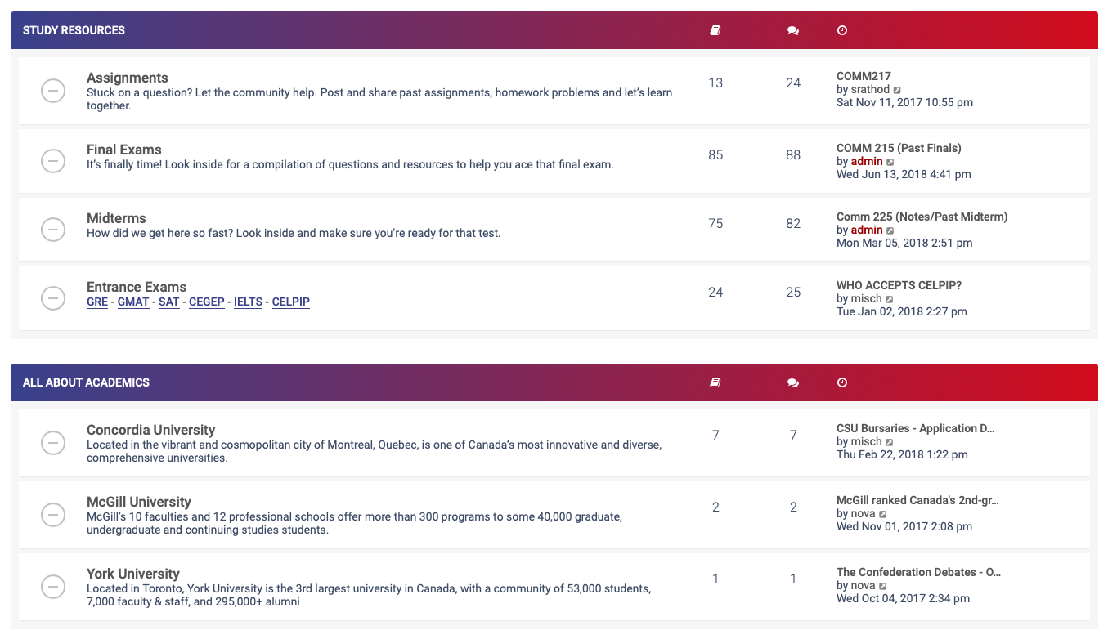

While having a forum is a nice way for students to discuss issues and general thoughts to each other, it seems that this particular forum has been inactive since 2018, with some posts receiving over 20,000 views and no replies, suggesting that while many students visit the forum, only a very small amount of students interact with its content, drawing the necessity of this particular feature into question.

Adjacent to the forum is an FAQ section, in which a predetermined list of questions has been answered. This helps provided students a quick glance at answers if they see their question listed, with contact information being provided at the end of the page if their question was not found: 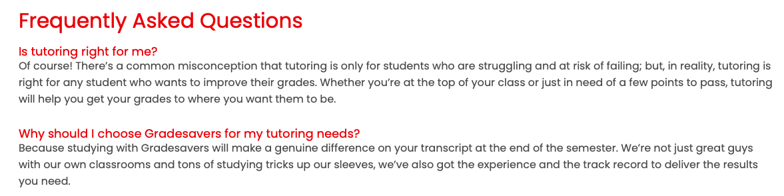

1. **Website design and navigability**

The website, hosted by external online marketing and hosting company Digiclimber, is designed to have students find the courses they need help in as fast as possible. The first interactive part of the website visitors are presented with is a search bar, prompting the user to search their specific course to find a tutor: 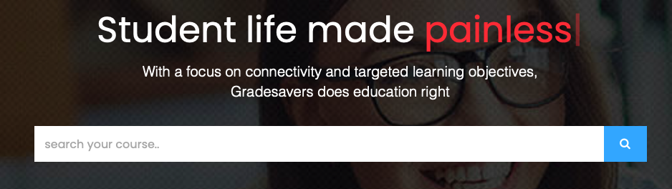

Below this section is a small introductory video/skit meant to convince people that the atmosphere of a class at their location is less formal than at university. Below this section is a “Popular Courses” section, in which classes are listed in terms of their demand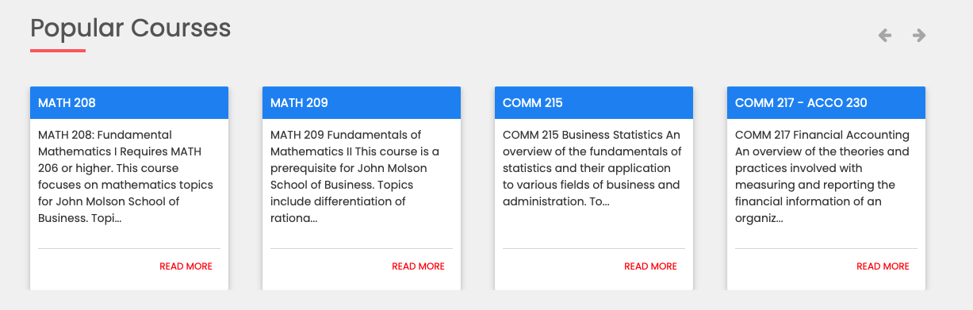

This would make the process of trying to find these specific courses much faster, as pressing on the “Read More” option immediately redirects students to the tutoring options available for the specific course.

In conclusion, the GradeSavers website, options and layout is designed to streamline the student to tutor matching process. By breaking down the website options into institutions, domains, courses, and tutoring options, this helps students find the resources they are looking for as fast as possible without the need for external consultation or a message to the tutor directly. All in all, GradeSavers has created a simplistic website with some redundant features but seems to tailor its experience on the fact that students are visiting the website already knowing the course they want tutoring help in, as there is no “general tutor” option present.

**I.II Comparative study of** [**turomatch**](https://www.tutormatch.me/)

Tutormatch.me is a web-based tutor-matching service apparently owned by Growth Empowerment INC. The website offers an easy-to-use tutor-matching service that can be used by students and tutors alike. The service does not focus on a specific level of education or institution, instead offering its services for any level of education from primary school to university-level and professional development.

1. **Website interface & Tutor Search**

The website provides a stream-lined, minimal, and easy-to-use user interface for both tutors and students. Students/parents can navigate the website to search for tutors and view tutor details without the need to register as a user. The interface to search for a tutor is stream-lined and has 4-5 fields to select, with some being optional such as ‘city’. Some search fields vary depending on whether the option for ‘online tutor’ or ‘in-person tutor’ is selected. 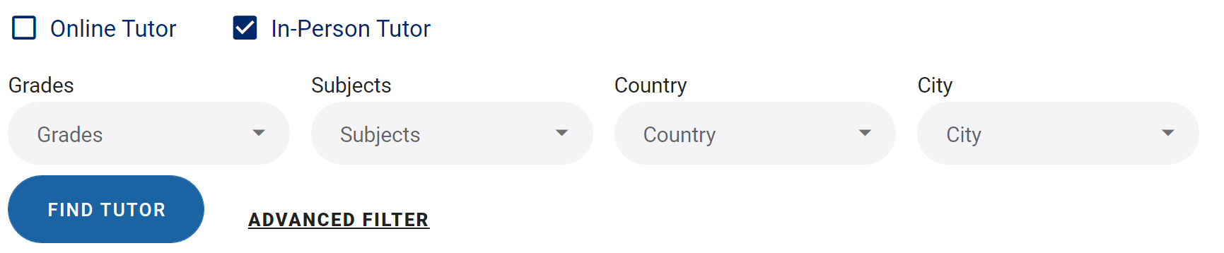*Figure 1: Search for Tutor Interface*

1. **Tutor Search Results and Details Page**

The tutor search results are organized and concise, containing useful information about each tutor that meets the selected search fields. The returned information about each tutor includes the location of the tutor, the name of the tutor, the price per hour of tutoring, the level of education of the tutor and the amount of experience tutoring.

*Figure 2: Search result example* Each search result contains a button to view details of the specific tutor. Selecting this button brings the user to another page that shows additional information about the tutor. This details page of the selected tutor shows information including all subjects and education levels that the tutor can teach, the session pricing options, and the tutor’s availability.

1. **Tutor Registration**

Users can easily register to be a tutor listed on this website. Registration can be done by selecting the ‘I’m a tutor’ option from the homepage and then selecting ‘sign up’. Selecting ‘I’m a tutor’ opens a new page that provides concise details of each major feature offered for tutors. Before filling the form to become a tutor, a user account must be created. Once this is done, the tutor can fill the registration form with information about themselves including level of education, personal information, subjects they can tutor and their availability.

1. **Tutor Features**
2. **Integrated calendar and appointment booking**

The online calendar feature shows the upcoming tutoring sessions that the tutor has booked in a clear visual calendar.

*Figure 3: Online calendar*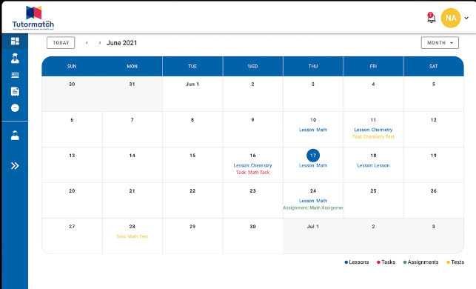

1. **File management and lesson plans**

This feature includes a cloud storage system which allows tutors to upload and organize files that they can organize into lesson plans. Another feature is ability for tutors to create an organize lesson plans by subject and level.

*Figure 4: Managing lesson plans*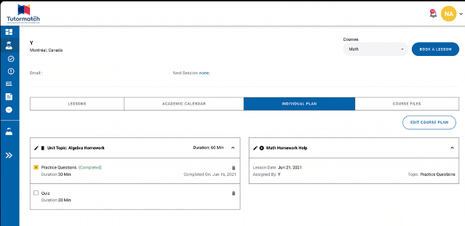

1. **Payment system**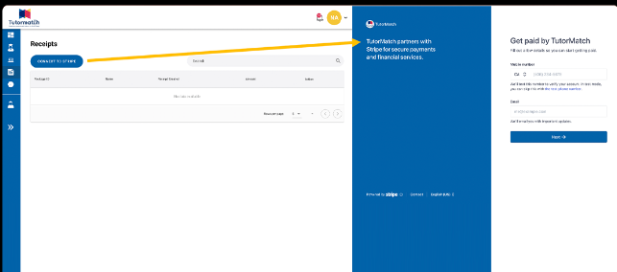

*Figure 5: Online payment system*

This tutor service has a fully integrated payment system which allows students/parents to pay for the tutoring services through the website. The payment system allows the tutors to see the status of the payments and the payment receipts.

**I.III Comparative study of the Varsity Tutors website** [<https://www.varsitytutors.com/ca>]

1. **Applying for becoming a tutor**

The Varsity Tutors website does not have a feature allowing Guest users to apply for a tutoring position. Not all Guests who visit the website are looking for tutoring, some Guests might want to tutor students. In this case, it is required for the website to have a page for uploading potential tutors’ CV, cover letter and contact information. Our website will have a web page designated for accepting applications for becoming a tutor. This will allow the Guest user to submit a CV along with their personal information such as their name, address, email and phone no. so the admins can later contact them for interviews.

1. **Communication via email instead of calls**

The Varsity Tutors website redirects the Guest user to enter their phone no. whenever they click any link on the website so they can later call the Guest user to discuss further information about their services. This design may not allow students, parents, or other users to get a gist of what is being offered by the tutoring service initially before deciding whether they want to go ahead with this tutoring service. It is necessary for users to get a general idea of what is being offered to them before committing to a phone call with a representative as phone calls may be time consuming and users may be discouraged from getting further information if they have busy schedules and are unable to answer the call.

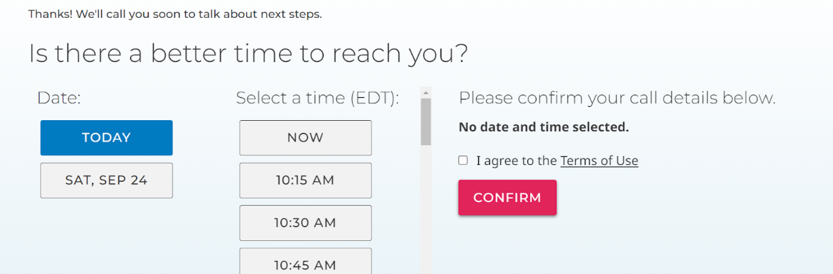Figure: <https://www.varsitytutors.com/ca>

Our website will handle most user sign-ups over email instead of calls and connect users to tutors via email or chat. Once the student or parent or guardian has chosen the tutor, a meeting link will be sent via email to the tutor as well as the student or parent. This link can be used to conduct the tutoring lessons.

1. **Sign-up process**

The Varsity Tutors website has an easy and intuitive sign-up process. Instead of having to fill a long form, the website asks the user one question at a time and decides the next question based on their response to the first question. For example, first the Guest user is asked if they are Parent/Guardian or a Student. The website then gradually proceeds to get their contact information and some other information for their profile. Finally the website asks questions on what kind of tutoring the user needs or what subjects the user may be interested in. Our website will follow a similar format for user sign-ups so as to make the sign-up process as simple as possible for the student, parent or guardian or any other type of user.

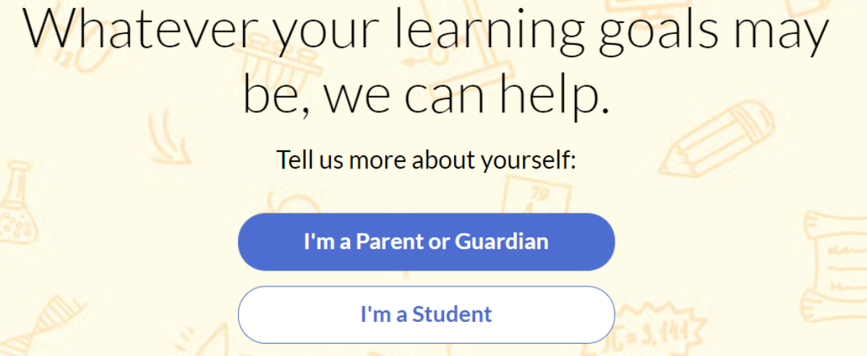

Figure: <https://www.varsitytutors.com/ca>

**I.IV Comparative study on** [Kumon](https://www.kumon.com/ca-fr/emplacements) **tutoring center**

Kumon tutoring is a franchise tutoring center that has physical locations and recently started giving the option to have online sessions. Kumon claims to have a certain method to their tutoring services. Their website is interactive and is easily translatable.

1. **Website design & Navigability**

On their homepage they have a navigation bar with clear options to navigate easily on the website. The options on the Nav bar are clear and concise, with great use of organization in separating the information. They also created a downloadable flyer with information about their sessions as well as coupons to save on courses offered by the center.



They offer courses for many different age groups, from kindergarten to highschool level education. On the homepage they have categories of different ages clearly separated, also allowing the user to also minimize that section of the homepage and not scroll through the whole homepage.



They have a “how to” page that explains how to navigate their website and how to book a session with a tutor. They give a step by step sequence for the user to easily follow for every student’s need. They also offer an orientation session to help the users situate themselves and easily understand the process as well as how the classes/session will take place. 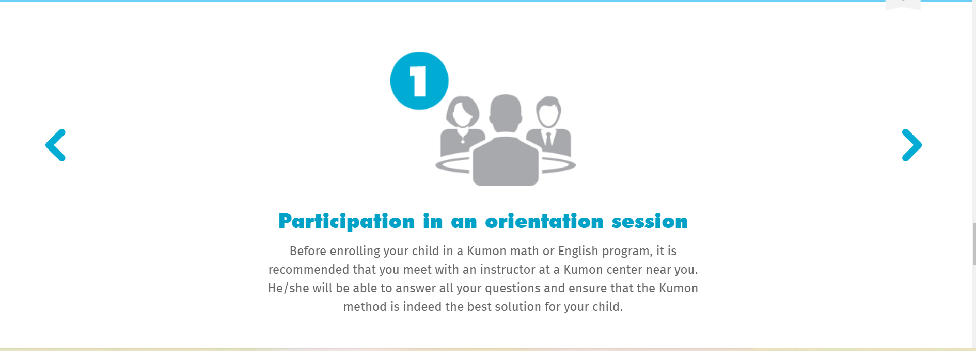

1. **Communication & Bookings**

Bookings and communication can be done by phone call or directly on the website by entering your home address and the website locates the nearest tutoring center to your location. With your location you can then book a session at the location franchise.

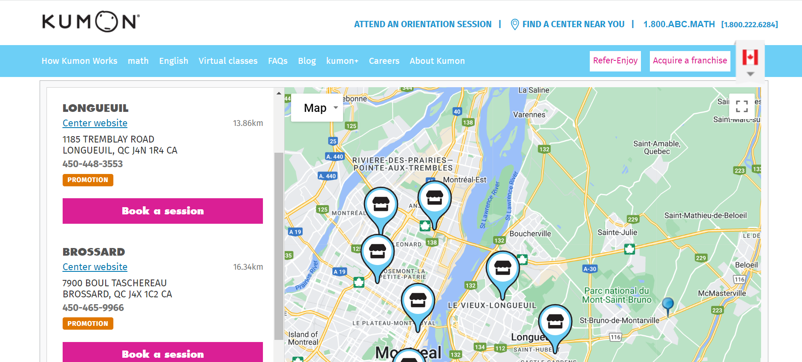

They also recommend the student and parent attend the orientation session and the student will have a free assessment test to gage the student’s level. This assessment serves the tutor to understand the needs of the student and where the difficulty lies to create a more appropriate program to the given student.

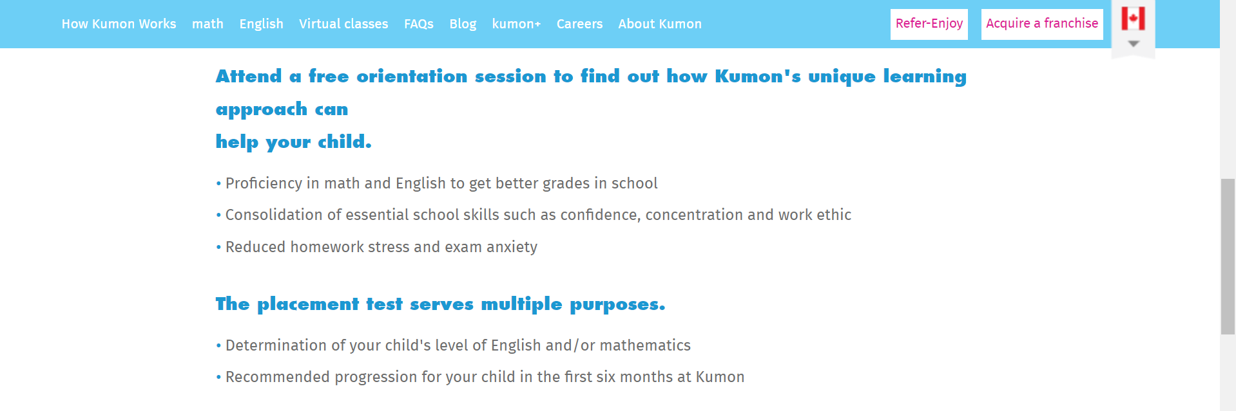

Kumon tutoring only offers two subjects, Math, and English, therefore not giving too much variety to their clients. However, this makes it easier for the Kumon tutoring center to have a method of study and acquire specialized tutors in only 2 subjects. It is easier to manage and handle as a franchise.

1. **Careers/Tutors**

This tutoring platform has a page dedicated to recruiting tutors. The website presents its tutoring responsibility as a promising career within the company highlighting all the benefits it may bring to their tutors. They also offer the option to open up a Kumon center and be part of the franchise and also additional jobs within the company.

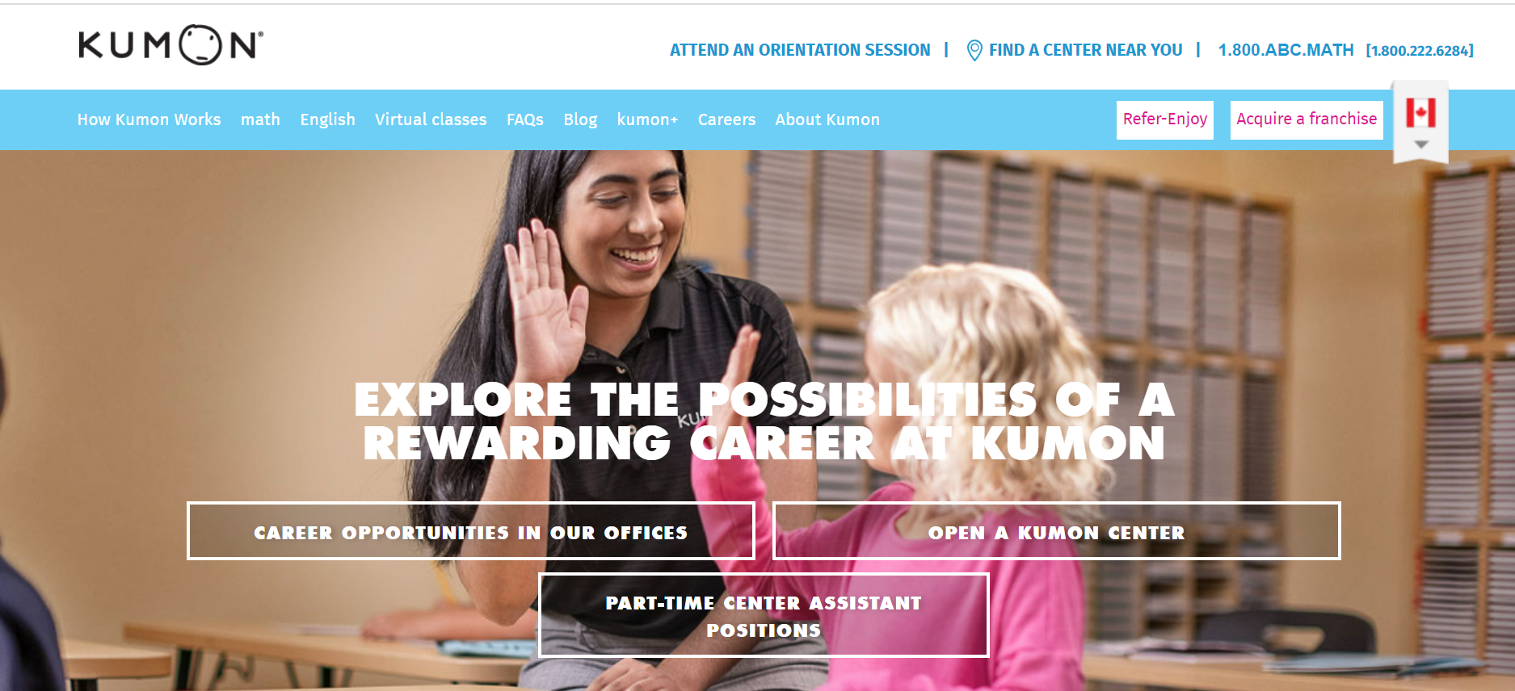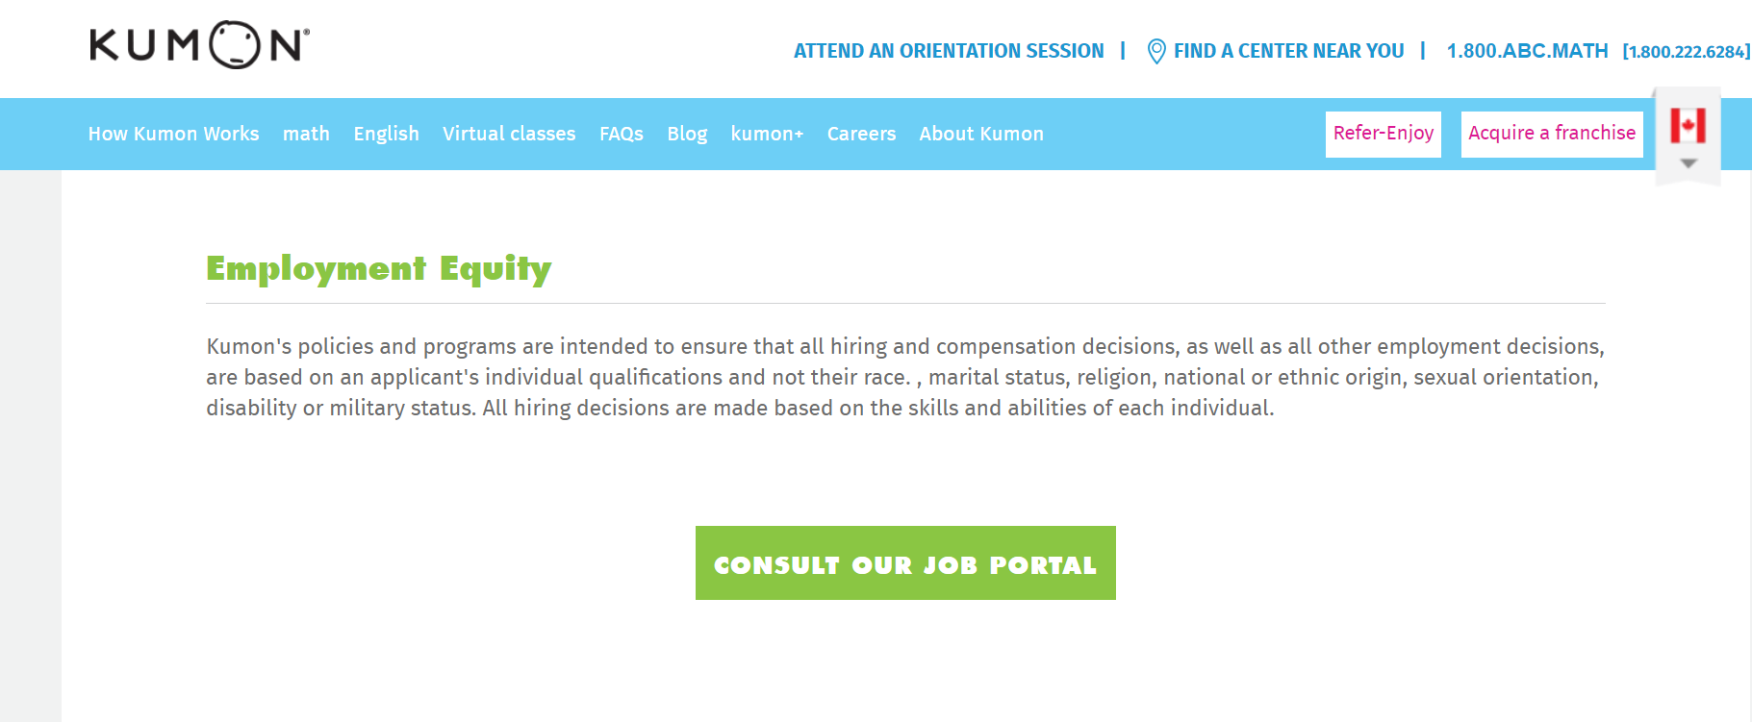

1. **Unique Features**

They have a rewards page where if a student is enrolled in a program they can earn points that they can use in the reward program. This is a good marketing method since the user needs to be enrolled in a program which consists of many sessions and it motivates the students to work hard and continue with the program to earn rewards with special prizes. They advertise this on their KUMON + page which is a bonus program for their recurrent clients.

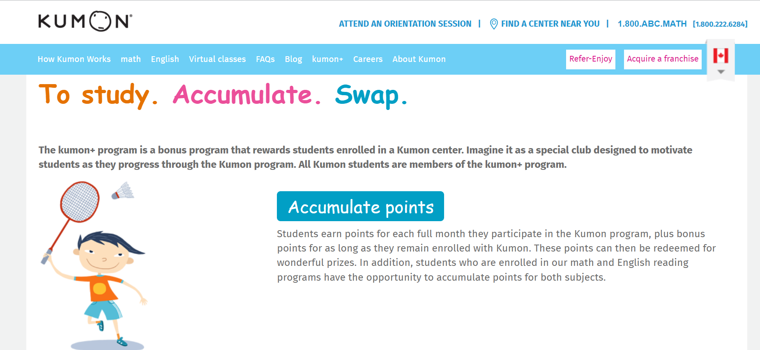

**Comparative Study Summary Table**

|  |  |  |  |  |  |  |  |
| --- | --- | --- | --- | --- | --- | --- | --- |
| **Website** | **Sign-up as a Tutor** | **Specific Institution/ Specific Course** | **Registration required to navigate the website** | **Discussion Forum** | **Specific Subject** | **Tutor Qualifi-cation Page** | **Focus** |
| **GradeSavers** | N**o** | Yes | No | Yes | No | No | University/College |
| **Tutormatch** | Yes | No | No | No | Yes | Yes | None |
| **Varsitytutors** | No | No | No | No | Yes | Yes | University/College/High School |
| **Kumon** | No | No | No | No | No | No | Elementary/High School |

**Part II: E-Academy presentation**

In the E-Academy system, each role would have access to a different set of features tailored to their needs. There are currently four roles to be considered: tutors, admin, student and guest.

### Tutors

1. Build a profile
   1. Tutors should have their own profile where they add information about themselves such as: education, alma mater, short description, past teaching/work experience. (all of this can be used for connecting students with the appropriate tutors for their level and field of study).
   2. Tutors should select the subjects and levels of study which they can teach.
2. Manage meetings with students
   1. Tutors should be able to view and edit all the meetings they have with their students.
   2. Tutors should be able to create meetings with new students requesting lessons.
   3. Tutors should be able to see relevant information about students requesting a lesson such as needs or disabilities and access to technical services.
   4. Tutors should be able to accept or decline requests.
3. Stats summary
   1. Tutors can view how many sessions they've accepted and declined.
   2. Tutors can view how many hours they’ve worked and how much money they’ve earned.
   3. Tutors can view the status of a payment for a session.

### Admin

1. User profile management

* An administrator should be able to keep track of all user profiles within the system including usernames and passwords among others.

1. Security and permission

* Administrators should be able to give or take access to certain features or certain files/folder to users depending on their level of security and which type of users they are.

1. Audit

* Administrators need audits to keep track of all user actions and data in case records of that use is needed.

1. Selection of tutors

* Admin would write an evaluation for the tutor selection based on the subject. The grade from the exam will determine whether the tutor will be allowed tutor.

1. View and Manage data

* Admin should be able to view and manage data on students and tutors in general
* Admin should also be able to view and manage data from the shared dashboard in order to ensure a certain level of efficiency.

Our website would be different from others in which administrators could have an admin panel/back-page where all these tasks could be done. Such as being able to change access to tutors/students from that panel when needed.

### Student

Students are the main customers of the E-Academy platform. They register on the website, and request tutoring from tutors for a fee. The features that they have access to should contribute to being able to find and match with tutors suiting their needs, and to have tools that help with their learning.

#### Features Summary

1. Build a profile
   1. When first logging in, students should be asked their current level of education
   2. Students should be asked what areas that they need help with
2. List tutors
   1. Students should have a list of tutors that they can browse through and select.
   2. Students should be able to filter for a tutor of a subject that they specify.
   3. Students should also be able to filter a preference for a tutor who is from the same school as them.
   4. Students should be given recommendations based on the profile that they built
3. Scheduling lessons with tutors
   1. When selecting a tutor, students should be able to see the tutors’ availabilities that match with their own.
   2. Students should be able to select a timeslot with a tutor to schedule a lesson

#### Scenario

1. The student logs into their account for the first time.
   1. The website asks the student their level of education (high school, cegep, university).
   2. When the student returns their level of education, the website displays a new page and asks the student the areas that they need help with.
   3. When the student returns their answer, the website saves the information and displays the student dashboard to the student.
2. The student wants to find a tutor for General Chemistry
   1. The student clicks the “Find tutor” button on the student dashboard.
   2. The website asks the student the area that the student needs help with.
   3. When the student returns the area that they need help with, the website displays a calendar of the next two weeks and asks the student to select all time slots that they are available.
   4. When the student returns their availabilities, the website filters tutors that do not have matching availabilities and displays a list of tutors sorted by availability overlap with the student.
   5. The website asks the student to select a tutor in the list and gives the option for the student to add additional filters (e.g. filter by school).
   6. When the student returns a selected tutor, the website displays the timeslots that overlap between the tutor and student, and the website asks the student to select a timeslot.
   7. When the student returns a timeslot, the website registers the meeting and sends a meeting confirmation email to both student and tutor.

### Guest (everyone has access to it)

1. View

* Guest users should be able to surf the website and see the different options offered, general information regarding the websites and its usage
* The guest user should also be able to see the different tutors and their rate per hour as well as their areas of expertise/ what they are tutoring.
* The rating of each tutor will be shown below each tutor’s profile so any user can see what people have thought of them.

1. New Tutors

* Guest tutor will be able see the different area of expertise needed and what type of users are using the service.

## Global Features

There are features that are common between all roles which will be described in this section.

#### Features Summary

1. Registration
   1. All roles must be capable of creating an account.
   2. There should be a form to sign up with a name, email and password.
   3. There should be a button to sign up with external services like Google where the user information is retrieved from their external account.
2. Login
   1. All roles must be capable of signing in to their account.
   2. If their account was created with a name, email and password then they should be able to log in by entering their email and password in a form.
   3. If their account was created through an external service, they should be able to log in by clicking a button that allows them to log in through the external service.
3. Reset password
   1. All accounts created with a name, email and password should be allowed to reset their password.
   2. There should be a button in the login page that allows a user to reset their password.
   3. The user must enter their email address in a form, then a reset password link will be sent to their email address.
   4. When accessing the reset password link, the user should see a form where they can enter their new password twice and a button to confirm the change.
4. Meeting calendar and page
   1. There should be a web calendar that displays all the meetings that the user is scheduled for, whether they are a tutor or student.
   2. When clicking on a meeting in the calendar, a page should display with buttons to reschedule or cancel meetings.
5. Meeting whiteboard
   1. Both tutor and student should have access to a virtual whiteboard when they are in the meeting.
   2. They should be able to draw with different colored markers on the virtual dashboard.
   3. There should be an eraser tool to remove markings from the whiteboard.
6. Meeting upload/download documents
   1. Both tutor and student should be able to upload and download documents in the meeting page.
   2. When in a meeting, the documents list should be displayed alongside the whiteboard so that either student or tutor can upload or download documents.

#### Scenario

1. Student wants to register
   1. The student clicks on the “Register” button in the home page.
   2. The website displays a form and asks the student to enter their email address and the same password twice.
   3. When the student returns the registration information, the website sends an email to the email address provided with a link to confirm the registration.
   4. When the student clicks on the link provided in the email, the student is directed to the student dashboard.
2. Student wants to log in
   1. The student clicks on “Log in” button in the home page.
   2. The website displays a form and asks the student to enter their email and their password.
   3. When the student returns the login information, the website redirects the student to the student dashboard.

**Elicitation Techniques:**

In light of the development of this tutoring service, a study of other such platforms for comparison and improvement was suitable. As such techniques were used that allowed the gathering of adequate information from existing as-is systems for our system-to-be.

The first elicitation techniques were artifact driven and furthermore a representative sample of existing as-is systems was used to ensure the well rounded and dynamic acquisition. The technique was domain-specific knowledge reuse as there were many abstract domains such as concepts, tasks, and actors. The goal of this technique was to quickly gather knowledge and experience from other related systems such as Kumon tutoring center, Turomatch and Gradesavers in order to reformulate, adapt and integrate said gathered knowledge for the needs of the system-to-be.

The second elicitation technique is stakeholder driven. The technique is conducting interviews. As such, we interviewed stakeholders in select fields to acquire information from that said field. In order to retrieve the desired data, a mix of structured and unstructured interviews were used as a way to have a set of questions specific to the interview’s purpose along with allowing open-ended questions and open dialogue about as-is systems currently in use.